ORC Asian Championship
NOTICE OF RACE
SooYoung Bay, Busan, Korea, 1st May – 5th May 2014

1 Organizing Authority

The ORC Asian Championship is organized by the Busan Sailing Federation in conjunction with Busan Metropolitan City, Sungwoo Hightech.Co., Ltd under the authority of Korean Sailing Federation and under the overall authority of the Offshore Racing Congress (ORC).

2 Rules

2.1 The regatta will be governed by the rules as defined in The Racing Rules of Sailing.

2.2 The following rules will also apply:

a) IMS Rule
b) ORC Rating Systems Rule
c) ORC Championship Rules
d) ISAF Offshore Special Regulations for Category 3

2.3 No national authority prescription will apply.

2.4 If there is a conflict between languages the English text will take precedence.

3 Classes

ORC 1 | ORC 2
ORC International  (Corinthian Division) | ORC Club

4 Advertising

ISAF Advertising Code will apply. Competitors & Boats advertising will be without restriction. Event Advertising by the Organizing Authority will be:

- bow numbers with advertisement which have to be displayed as forward as possible on the both sides of the first 20% of the hull
- advertisement to be displayed on the both sides of the foremost 20% of the mainsail boom
- sponsor’s flag that has to be flown on the backstay throughout the entire event.
- advertisement by Organizing Authority to be displayed on hull centre.

The Organizing Authority may also require the installation, at no cost to competitors, of onboard video cameras, position devices, and guest riders whose on-board position restrictions are defined in the Sailing Instructions.

5 Eligibility

5.1 Competitors shall comply with ISAF Eligibility Code. The regatta is open to all boats with valid ORC International certificate with GPH in range of 400.0 – 660.0 s/NM. In case of larger number of entries boats will be divided in classes with separate results. GPH limits to divide the fleet will be decided based on entries received by 18th April 2014. The ORC Asian Champion title will be awarded in ORC International category.

5.2 Organizer may reject the entry for the reasons of safety, sportsmanship or any others.

6 Corinthian Division and Trophy

For the Corinthian Division and Trophy the ISAF Sailor Classification Code, Regulation 22 shall apply and all crew shall hold a valid Group 1 classification. Unclassified sailors will be deemed to be Group 3. A boat entered in the Corinthian Division shall also be entered automatically in the Open Division and shall be eligible for prizes and trophies in both divisions. Details of the ISAF Sailor Classification Code and information on how to apply can be found on the ISAF website: www.sailing.org/classification.

The closing date for the receipt of valid Corinthian entries shall be 18th April 2014. Each entry shall include a complete crew list and show the classification and ISAF Sailor ID for each crew. All crew shall hold valid classifications prior to this date that do not expire until after the final day of the regatta. Late entries and incomplete entries cannot be considered for this division.

Should a boat whose Corinthian entry has been checked and accepted need to change a crew member between the closing date of the entry and the start of the regatta, the name of the new crew member with their valid ISAF Sailor ID must be submitted to the Organizing Authority for their approval [and for the approval of the International Jury]. All crew lists will be posted on the Official Notice Board or website as soon as possible after the Registration deadline.

Note: A representative of the ISAF Sailor Classification Commission will be present during registration and will carry out spot checks. Competitors shall attend interviews with the Commission when requested to do so. Competitors are reminded that the Commission has the power to change a classification at the event with no prior notice. Any changes are effective immediately.

6 Entries and Entry Fee

6.1 Eligible boats may enter by completing the attached form and sending it to the:

Busan Super Cup International Yacht Race 2014 Organizer
Address | 1393 U-dong, Haeundae-gu, Busan city, Republic of Korea Postcode 612-824
Telephone | +82 -51- 747- 1768 | Fax | +82-51- 746- 1793
E-mail | sailingbusan@gmail.com | Website | www.busansupercup.or.kr

with a copy of the yachts rating certificate before 18th April 2014.

6.2 The non-refundable entry fee should be bank transferred to

Account Name | Busan Sailing Federation, | Swiftcode | PUSBKR2P,
Account Number | 171-01-000547-7 | Bank Name | Busan Bank

or direct payment to organizer’s office

6.3 A boat is considered to be Pre-registered if the following documents are received before 11th April 2014.

a) Completed and signed official entry form
b) Current ORC Certificate
c) Entry fee payment confirmation

6.4 The organizer is not responsible for any costs incurred by the non-acceptance of a boat’s registration.

6.5 Late entries may be accepted until 18th April with a late extra fee of 100.000 KRW at the discretion of the OA.
6.6 The race committee may limit the number of entries even before the closing day for the effective progress of race

6.7 The entry fee is 200,000 KRW per boat plus 20,000KRW per sailor.

7 Registration

7.1 Each Owner or Skipper must personally register in the Race Office located in Busan Super Cup International Yacht Race 2014 Organizer from 10:00 1st May 2014 to 12:00 2nd May 2014.

1st May | 10:00 ~ 18:00
2nd May | 10:00 ~ 12:00

7.2 The following documents shall be presented at registration:

a) Valid ORC International certificate issued before 29th April 2014
b) Valid third-party insurance
c) If advertising is displayed, a respective National Authority permission
d) Crew list with name, surname, national sailing licence number and weight for each crew member
e) Contact phone number both on boat and land, including the name of contact person
f) Liability acceptance form, duly filled out and signed
g) Certificate of Ship’s Nationality, Deratting Exemption Certificate for CIQ procedure

This changes RRS 78.2.

7.3 No changes shall be made on ORC International certificates after 2nd May 2014 unless prescribed by the Measurement Committee and International Jury’s approval.

7.4 Measurement protests by the boats shall be accepted up to two hours after the posting of the final ratings.

7.5 Crew lists may be amended up to 2nd May 2014 at 12:00 by filling a new form showing the changes. After this time, changes in crew may be made only with the written permission of the International Jury.7.6 Protests by boats regarding ISAF Sailors Classification Code shall be accepted up to 2nd May 2014 at 12:00.

8 Schedule

8.1
DATE | SCHEDULE
29th April (Mon) ~ 30th April (Wed) | Pre- Measurement
1st May (Thu) | Registration and Measurement
2nd May (Fri) | Registration and Measurement / Inshore races
3rd May (Sat) | Inshore Races / Opening Ceremony
4th May (Sun) | Offshore Race (40 miles)
5th May (Mon) | Inshore Races, Prize giving

8.2 Seven races are scheduled including one offshore race and six inshore races. Inshore races will be windward/leeward races, except where unusual or extreme local conditions make it impossible to sail a windward/leeward course, then the International Jury may give permission to sail a substitute course.

8.3 Inshore races will be of 1.5 – 2 hours duration and shall have scoring coefficient of 1.0. Offshore race will be of 10 – 12 hours duration with scoring coefficient of 1.2.

8.4 The championship is valid if at least 3 inshore races and the offshore race are completed. One discard will be allowed if 5 races are completed, but the offshore race shall not be discarded.

9 Measurement

9.1 Each boat shall be available for the measurement and inspection from 1st May 2014 at 09:00 until 2nd May 2014 at 12:00. Measurement and rules compliance inspections will be carried out throughout the championship before or after each race with emphasis on boats well placed in the scoring. The inspection will also include freeboards whenever possible.

DATE | TIME
29th April | 13:00 ~ 18:00 | Pre- Measurement
30th April | 09:00 ~ 18:00 | Pre- Measurement
1st May | 09:00 ~ 18:00 | Official Registration and measurement
2nd May | 09:00 ~ 12:00 | Official Registration and measurement

9.2 ORC international boat may apply for the certification at pre-measurement period.

10 Sailing Instructions

Sailing Instructions will be available for each entrant at completion of the registration formalities.

11 Scoring

11.1 Windward/leeward race results will be determined by corrected times calculated by Performance Curve Scoring.

11.2 Offshore race results will be determined by corrected times calculated by one of the available methods according to the wind conditions.

11.3 The Low Point Scoring System of RRS Appendix A. Points will be multiplied by the appropriate scoring coefficient.

12 International Jury

An International Jury appointed according to the RRS Appendix N will supervise the event; with no right of appeal according to the RRS 70.5.

13 Nautical charts

The following nautical charts of the Korea Hydrographical and Oceanographic Administration are utilized as a reference in the Sailing Instructions: K-2131, K-2153. Please refer to www.chartkorea.com for availability.

14 Moorings

Free allocated berthing will be provided from 12:00, 26th, April to 12:00, 11th, May at Busan Yachting Center Marina in front of organizer’s office.

15 Registration of arrival

15.1 CIQ procedure shall be supported by the organizer to boats arrived at 28th to 30th April.

15.2 Certificate of Ship’s Nationality and Deratting Exemption Certificate shall be provided by foreign boats for CIQ procedure.

15.3 Other information for CIQ shall be found at the organizer’s homepage.

16 Media rights

Competitors, owners and their guests give absolute right and permission to the Organizing Authority for any photography and video footage taken of persons and boats during the event, to be published and/or broadcast in any media, including but not limited to TV advertisements, whatsoever for either editorial or advertising purposes or to be used in press information.

17 Communication

Except when communicating with the Race Commitee, a boat while racing, shall not transmit or receive communication of any information not publicly available to all boats participating.

18 Trophies and Prizes

Trophies shall be awarded to ranked boats from 1st to 3rd and prizes for 1st to 5th.

19 Disclaimer of Liability

All those taking part in the regatta do so at their own risk and responsibility. The Organizing Authority, Busan Sailing Federation, Korean Sailing Federation, ORC and any other party involved in the organization of the ORC Asian Championship disclaim any and all responsibility whatsoever for loss, damage injury or inconvenience that might occur to persons and materials, both ashore and at sea as a consequence of participation in the event. Each boat owner or his representative accepts these terms by signing entry form. The attention of competitors is drawn to ISAF Part 1 Fundamental Rule 4: A boat is solely responsible for deciding whether or not to start or to continue racing.

20 Insurance

Each participating boat shall be insured with valid third-party insurance. Regardless, it is the responsibility of the owners to hold adequate insurance cover for Tort Liability and Third Party Insurance (Property and Persons).

21 Subsidy

21.1 Subsidy will be provided according to sailing distance to venue as follows.

Distance | Amount
Less than 20miles | 300,000 KRW
Over 20miles | 500,000 KRW
Over 50mies | 1,000,000 KRW
Over 100miles - | 1,500,000 KRW
Japanese | 1,500,000 KRW
Overseas (Chinese , Russian , etc.) | 2,000,000 KRW

21.2 Subsidy for foreign boats moored at harbour in Korea is 1,000,000 KWR.

22.2 Competitors or boats apply for the subsidy has to submit the copy of “report for long distance water activity” to organizer. The report is the document reported to Korea Coast Guard on your departure area.

22 Race Area

Refer to following diagram for race area; Circle is for the inshore races whereas long lines with arrow is the offshore race course.

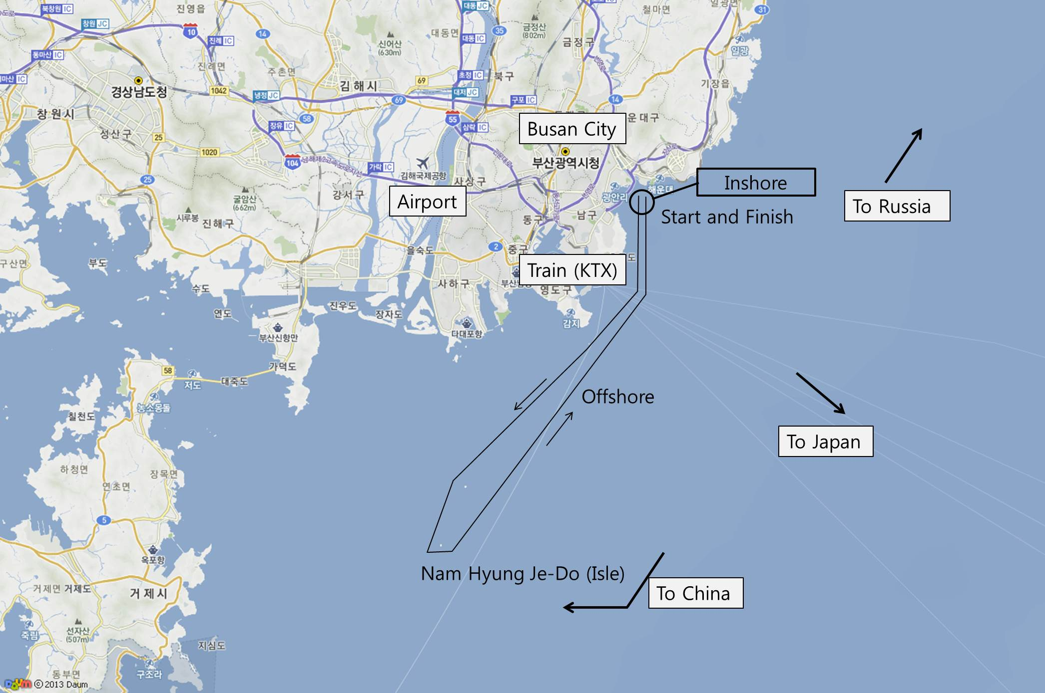

23 Accommodation

BSF recommends

Arpina
35 Haeundaehaebyeon-ro (U-dong), Haeundae-gu, Busan
Tel: +82 (0)51 731 9800
Fax: +82 (0)51 740 3225
Homepage: www.arpina.co.kr

Seacloud Hotel
287 Haeundaehaebyeon-ro (U-dong), Haeundae-gu, Busan
Tel: +82 (0)51 933 1000
Homepage: www.seacloudhotel.com

Grand Hotel
217 Haeundaehaebyeon-ro (U-dong), Haeundae-gu, Busan
Tel: +82 (0)51 7400 114
Fax: +82 (0)51 7400 115
Homepage: www.haeundaegrandhotel.com

Local accommodation information is provided at Haeundae-gu Office
Homepage: eng.haeundae.go.kr

24 Further information

This Notice of Race may be amended, with changes posted on the event website.
For any further formation please contact bsaf@bsaf.or.kr.

