Korea Cup Int’l Yacht Race 2016
HupoUljin – Dokdo - HupoUljin, Korea
30th August– 4th September 2016
▪ Host: Korea Sailing Federation(KSAF)
▪ Organizing Authority: Korea Cup International Yacht Race Organizing Committee, Gyeongsangbuk-do Yacht Federation.
▪ Sponsors: Ministry of Culture Sports and Tourism of Korea, Korea Sports Promotion Foundation,
Gyeongsangbuk-do, Uljin-gun

NOTICE of RACE(Inshore Open Race)
1. RULE
1.1 The regatta will be governed by the rules as defined in The Racing Rules of Sailing(RRS) 2013-2016.
1.2 ISAF Offshore Special Regulations 2016-2017 Category 4 will apply for the Korea Cup Inshore Open Race.
1.3 KSAF Performance Handicap Rating Fleet (PHRF) for Open Class.
1.4 The National Prescription 2 will apply. (If an incident results damage or injury that is obvious to the boats involved, the boat found to have breached rule by the protest committee shall be responsible and compensate for it. However, the protest committee may decide proportion of necessity.)
1.5 If there is a conflict between languages the English text will take precedence.
2. ADVERTISING
2.1 ISAF Advertising Code will apply.
2.2 A boat shall display the bow numbers with advertisement, stay flags and other advertisement provided and instructed by the Organizing Authority in accordance with this Notice of Race and the Sailing Instruction.
2.3 The Organizing Authority may also require the installation, at no cost to competitors, of on board video cameras, positioning devices, and guest riders. Failure to carry and operate a positioning device or to carry a camera when required will lead to rejection of an entry, the cancellation of an entry or the disqualification of the boat from the race (refer RRS 76.1).
3. ELIGIBILITY
3.1 Eligibility of Boats for the Korea Cup Inshore Open Race 3.1.1 Maximum 30 boats will be eligible to compete in the order of registration.
3.1.2 General requirements
(a) A boat shall:
• be single mono hulled and self-righting.
• have an overall length (LOA) not more than 30.48 meters and not less than 7 meters(23 ft);
• have a crew that satisfies the requirements of NoR 3.2.
• and comply with ISAF Offshore Special Regulations for Category 4.
(b) Each Korean boat shall be registered to the KSAF yacht registration system on the following website. http://ksaf.org/community/yacht/search/
(c) Each Korean boat shall be certified (Administration, Inspection, Insurance etc.) by Korean Boat related Law.
3.1.3 Eligibility boats – Safety Inspection
A boat may only be entered in the Inshore Open Race if the boat : Complies with all of the OSR Category 4 Rules. Hold conformity assessment from Safety Inspector. Sign and return a Safety Check List which all participated boat’s owner or skipper inspect themselves their boat by given Safety Check List(attached NOR) .
3.2 Eligibility of Crews for the Korea Cup Inshore Open Race
3.2.1 The minimum number of crews including skipper on a boat is 3 and all crews shall be more than 16 years old.
3.2.2 It is strongly recommended that at least 50% of the crews on a boat shall have completed a Category 4 race or higher, or an equivalent passage.
3.2.3 Disabled shall be a team from Korea Disabled Sailing Federation. More than 3 disabled crews can aboard only with more than 5 crews.
4. ENTRY and Event
4.1 Eligible boats may enter by completing the attached entry form and sending the following documents from 16th May to 15th July 2016. Dates and times are Korean Standard Time (UTC +9)
a) Completed and signed official entry form
b) ISAF OSR Category 4 – Safety Check List
c) Entry fee payment confirmation
d) Current ORC Certificate e) Photo of the boat in hi-res JPEG
f) Photocopy of insurance policy according to regulation 22 g) Declaration
4.2 Over entries may be accepted at organizer's discretion
4.3 Inshore race types are Inshore Open Kill Boat Race, and One Design Race(LCD2000 dingy-provided by Organizing Authority)
4.4 One design class will be held separately, if 5 or more same class of boats will be registered
4.5 Applicants should fill in the entry form regarding the NOR(category 4) and e-mail to the address below.
∙ Korea Cup Int’l yacht race Organizing Authority : 2016koreacup@naver.com
5. FEES
5.1 For the Korea Cup Main Event
The non-refundable entry fee per boat should be paid by bank transfer.
Total amount of entry fee is the sum of fee per boat plus per members (skipper +crews).
Entry | Entered from 15th June to 15th July 2016 | Entered from 16th July ~
Fee for  a boat | KRW 300,000 x 1boat | KRW 360,000 x 1boat
Fee for members | KRW 40,000 x Number of team members(skipper+crews)_ | KRW 48,000 x Number of team members(skipper+crews)_

[Bank Account Details]
• Bank: Suhyup Bank
• Account Name: Korea Sailing Federation
• Swift Code: NFFCKRSEXXX
• Account No: 1010-1100-8804
6. REGISTRAION
Each Owner or Skipper shall personally register in the Race Office located at the Hupo Harbor as per the following schedule.
7. SCHEDULE
date | time | Korea Cup Inshore Open Race
Aug. 22 | 10:00~ | Organizing Authority office available until 6th September
Aug. 22 | 10:00~ | Pontoons available for berthing until 9th September
Aug. 31 | 10:00~17:00 | Registration, Safety check
Sep. 01 | 09:00~10:00 | Skipper Meeting
Sep. 01 | 11:00~16:00 | Inshore Race - 1st day (3 races available)
Sep. 01 | 18:00~20:00 | Opening Ceremony
Sep. 02 | 09:00~10:00 | Skippers Meeting
Sep. 02 | 11:00~ | Inshore Race - 2nd day (3 races available)
Sep. 03 | 09:00~10:00 | Skippers Meeting
Sep. 03 | 11:00~17:00 | Inshore Race - 3rd day (3 races available)
Sep. 04 | 09:00~10:00 | Skippers Meeting
Sep. 04 | 10:00~17:00 | Inshore Race - 4th day (3 races available)
Sep. 04 | 18:00~20:00 | Prize Giving Ceremony
*CIQ Desk opens from 10:00 to 17:00 between 28th August and 31st August.
8. MEASUREMENT
8.1 A boat or equipment may be inspected at any time for compliance with certificates, KSAF PHRF class rules, special regulations, Notice of Race and sailing instructions.
8.2 Safety inspection period is 1st ~ 31st August 2016, and an inspector or race committee will contact the participated boat’s owner or skipper individually for inspection place, date and time.
9. SAILING INSTRUTIONS
Sailing Instructions will be provided to each entrant at completion of the registration formalities at the venue.
10. VENUE
Attachment A shows the location of the regatta areas.
11. RACING AREA AND THE COURSES
The diagrams in Attachment B show the racing areas, courses, including the approximate distance between the legs.
12. SCORING
12.1 RRS Appendix A3 shall apply.
12.2 Race results will be determined by corrected times calculated by KSAF(Korea Sailing Federation) Performance Handicap Rating Fleet(PHRF) where applicable.
12.3 Handicap rating under the KSAF Special Handicap Rating System shall be determined by the Race Committee, which will not be ground for a protest. (This changes RRS 61)
12.4 Final Score will be determined when 5 or more races have been completed, a boat’s series score will be the total of her race scores excluding her worst score. And when 4 or less races have been completed, a boat’s series score will be the total of her race scores. 12.5 One race is required to be completed to constitute a race.
13. INTERNATIONAL JURY
An International Jury appointed according to the RRS Appendix N will supervise the event, and decision of the jury will be final as provided in rule 70.5.
14. BERTHING
Boats shall be kept in their assigned places while they are in the harbor.
15. HAUL-OUT RESTRICTIONS
Keelboats shall not be hauled out during the regatta except with and according to the terms of prior written permission of the race committee.
16. MEDIA RIGHTS
Competitors, owners and their guests give absolute right and permission to the Organizing Authority for any photography and video footage taken of persons and boats during the event, to be published and/or broadcast in any media, including but not limited to TV advertisements, whatsoever for either editorial or advertising purposes or to be used in press information.
17. COMMUNICATION
Boats shall maintain a 24 hour listening watch for the duration of their race on the VHF Channel assigned by the Organizing Authority.
18. PRIZES
18.1 The Korea Cup Inshore Open Race Trophy and prize money will be awarded to the top 5 positions in each race group.
18.2 General Rule
(a) 10 % of prize money will be deducted to donate to charity.
(b) Income tax will be deducted as per tax agreement between Korea and the recipient’s country (4.4% for Korean). (c) After the race either skippers or ship-owners will be paid by wire transfer within 15days.
(d) The prize amount on the following prize chart may be changed in case of any changes on the Budget Plan of the Race.

18.3 Prize Money Table
Class | Position | Amount (KRW) | One design (KRW) | Daily Prize Giving Ceremony
OPEN | 1ST | 5,000,000/Trophy | 2,000,000/Trophy | Trophy for  1st position of each race
OPEN | 2ND | 4,000,000/Trophy | 1,000,000/Trophy | Trophy for  1st position of each race
OPEN | 3RD | 3,000,000/Trophy | 700,000/Trophy | Trophy for  1st position of each race
OPEN | 4TH | 2,000,000/Trophy | 500,000/Trophy | Trophy for  1st position of each race
OPEN | 5TH | 1,000,000/Trophy | 300,000/Trophy | Trophy for  1st position of each race
18.4 Other Prizes may be awarded at the discretion of the Organizing Authority.
19. TRAVEL COST SUPPORT
19.1 Each participating boat to the Korea Cup Inshore Open Race which complete all legs will be given the amount as per the table set forth in Attachment C. Each participating Inshore Open Race which complete less than 2/3 legs will be given 1/3 of the amount as per the table in Attachment C.
19.2 If Inshore Open Race is cancelled by OA due to bad weather or any condition beyond the reasonable control regardless of whether a boat has completed or not, each participating boat will be given the amount in full as per the table in Attachment C.
19.3 Travel cost support for Korea Disabled Sailing Federation is provided only if 3 or more disabled crews finish the race with 5 or more crews on aboard. 19.4 Organizing Authority may reduce the amount of travel cost support to a boat which has caused damage, loss, negligence or any form of mishap.
19.5 Regarding the Travel Cost Support, the amount of the following prize chart may be changed in case of any changes on the Budget Plan of the Race
20. SAFETY
Boats entering the Korea Cup Inshore Open Race shall comply with OSR Category 4.
21. DISCLAMIER OF LIABILITY
Competitors participates in the regatta entirely at their own risk. See rule 4, Decision to Race. The organizing authority will not accept any liability for material damage or personal injury or death sustained in conjunction with or prior to, during, or after the regatta.
22. INSURANCE
Each participating boat to the Korea Cup Inshore Open Race shall be insured with valid third-party liability insurance or valid Water Leisure Comprehensive Insurance for Korean participating boat.
23. FURTHER INFORMATION
For further information, please contact:
Korea Cup Int’l Yacht Race Organizing Committee c/o Korea Sailing Federation
#501 Olympic Center, 424 Olympic-ro, Songpa-gu, Seoul 05540, Korea
E-mail: 2016koreacup@naver.com
Tel. +82-2-420-4390 Fax. +82-2-420-4391

ATTACHMENT A – VENUE
Hupo Harbor, Hupo-ri, Hupo-myeon, Uljin-gun, Gyeongsangbuk-do, Korea
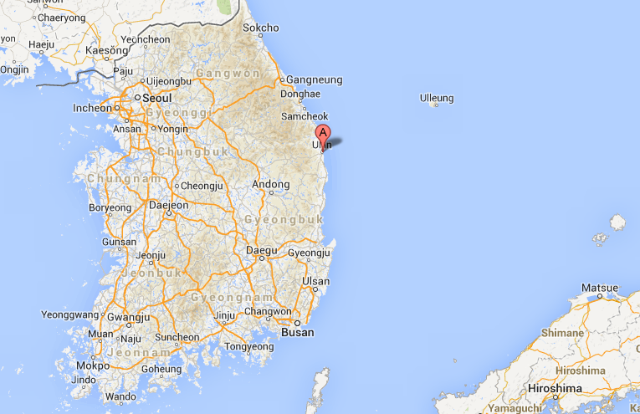
Location in Korea
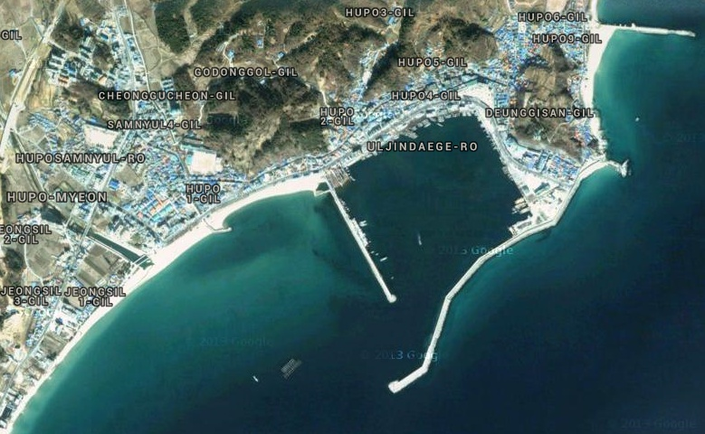
Race Office
Berthing Area
Berthing Area
for big boats
For Big boats
Hupo Harbor

ATTACHMENT B – RACING AREA AND THE COURSES
Coordinate of major point

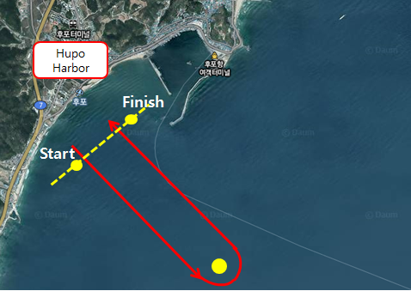

ATTACHMENT C – TRAVEL COST SUPPORT
Category |  | Distance  from the major cities | Amount (KRW)
 |  | Distance  from the major cities | Up to LOA  12 meters | More than LOA 12 meters
Korea Disabled Sailing Federation |  | Valid when 3 or more disabled crews with 5 or more crews in a boat. | 5,000,000
Abroad | 1,000Km and above | Qingdao China 1,057Km | 4,000,000 | 4,500,000
Abroad | Under 1,000Km | Vladivostok Russia 800Km | 3,000,000 | 3,500,000
Domestic | 800Km and above | Ttukseom Seoul 950Km | 3,000,000 | 3,500,000
Domestic | 800Km and above | Ullwangri Incheon 880Km | 3,000,000 | 3,500,000
Domestic | 600Km and above | Boryeong738Km | 2,500,000 | 3,000,000
Domestic | 600Km and above | Kyeokpo 682Km | 2,500,000 | 3,000,000
Domestic | 400Km and above | Mokpo 560Km  Seokwipo515Km | 2,000,000 | 2,500,000
Domestic | 400Km and above | Wando 440Km  Jejuhang498Km | 2,000,000 | 2,500,000
Domestic | 300Km and above | Yeosu343Km | 1,700,000 | 2,000,000
Domestic | 200Km and above | Tongyeong290Km | 1,500,000 | 1,700,000
Domestic | 100Km and above | Haeundae185Km  Susanhang177Km  Daepohang190Km | 1,000,000 | 1,300,000
Domestic | 50Km and above | Yangpo95Km  Samcheok 92Km | 500,000 | 500,000
Domestic | Under 50 Km | Ganggu 36Km | 300,000 | 300,000
- Distance is from the Departing Harbor to HupoHarbor in Ulljin.
- The distance is calculated by Organizing Authority.
- “Long distance water leisure Activity Report” will be used when calculation and OA may decide distance at their own discretion in special case.

KOREA CUP INT’L YACHT RACE 2016
30th August – 4th September 2016
HupoUljin – Dokdo - HupoUljin, Korea
[ENTRY FORM]

Please complete this form with the necessary documents per NoR and send to:
Korea Cup International Yacht Race Organizing Committee at 2016koreacup@naver.com
1. CLASS: □ ORC OFFSHORE RACE □ OPEN INSHORE RACE
2. BOAT
Boat name : |  |  |  | Maker / Model :
LOA: |  |  | Beam: |  | Draft :
Engine Maker& Model: |  |  |  | Engine Power (in hp):
Home Port: |  |  |  | Owner:
Arrival Date |  |  |  | Sail No.

3. Skipper
Name: |  |  |  |  | Address:
Nationality: Sex: |  |  |  |  | Telephone:
Passport No: |  |  |  |  | Mobile:
Height (cm): Weight (Kg): |  |  |  |  | Email:
4. Crews
No. | Name | Nationality. |  | Passport # |  | e-mail |  | Others
1 |  |  |  |  |  |  |  | Height(cm):  Weigh(kg): Sex:
2 |  |  |  |  |  |  |  | Height(cm):  Weigh(kg): Sex:
3 |  |  |  |  |  |  |  | Height(cm):  Weigh(kg): Sex:
4 |  |  |  |  |  |  |  | Height(cm):  Weigh(kg): Sex:
5 |  |  |  |  |  |  |  | Height(cm):  Weigh(kg): Sex:
6 |  |  |  |  |  |  |  | Height(cm):  Weigh(kg): Sex:
7 |  |  |  |  |  |  |  | Height(cm):  Weigh(kg): Sex:
8 |  |  |  |  |  |  |  | Height(cm):  Weigh(kg): Sex:
9 |  |  |  |  |  |  |  | Height(cm):  Weigh(kg): Sex:
10 |  |  |  |  |  |  |  | Height(cm):  Weigh(kg): Sex:
5. Bank Account Details of the skipper(Remittance of prize money and travel subsidy)
Bank: |  | Account Number:
ABA No: |  | Swift Code:
Account Name:  (Beneficiary) |  | Other Information:

6. Prize money

- I am aware that the prize money will be sent to the person above by bank transfer as per NoR 18.3 and all crew members are also aware of this.

Signature:

- I agree to NoR 18.3(a) 10% of prize money will be deducted for donation to a charitable organization OA appoints.

Signature:

Agreement : I agree to be bound by the ISAF Racing Rules of Sailing (RRS), the ISAF Offshore Special Regulations, ORC Racing rules and the Notice of Race and Sailing Instructions for the race(s) concerned.
Skipper’s name: |  |  | Signature: |  |  |  | Date:

DECLARATION

Name :
ID(Passport) No. :
Contact No. or E-mail :
Address :

By my signature I agree to be bound by the Racing Rules of Sailing and by all other rules that govern this event.
For following ISAF Racing Rules of Sailing(RRS) Part 1.4 ‘DECISION TO RACE’, I also agree that the Organizing Authority, Presenting, Sponsor and affiliated companies, and other sponsors will not accept any liability for material damage or personal injury or death sustained in conjunction with or prior to, during, after or before the regatta.

2016. . .

Name : (Signature)

