KoreaCupInt’lYachtRace2014

Hupo Uljin – Ulleung - Dokdo, Korea
3rd-10th October 2014

- Host: Korea Sailing Federation in conjunction with Uljin-gun, Ulleung-gun
- Sponsors: Ministry of Culture Sports and Tourism of Korea, Korea Sports Promotion Foundation
- Organizing Authority: Korea Cup International Yacht Race Organizing Committee

NOTICEofRACE

RULE
  - The regatta will be governed by the rules as defined in The Racing Rules of Sailing 2013-2016.

  - ISAF Offshore Special Regulations Category 3 will apply for the Korea Cup Offshore Race.

  - The following rules will also apply for the Korea Cup Offshore Race:
- ORC Rules for ORC class.
- KSAF Performance Handicap Rating Fleet (PHRF) for Open class

  - The National Prescription 2 “If an incident results damage or injury that is obvious to the boats involved, the boat found to have breached rule by the protest committee shall be responsible and compensate for it. However, the protest committee may decide proportion of necessity.” will apply. No other national prescriptions will apply.

  - If there is a conflict between languages the English text will take precedence.

ADVERTISING
  - ISAF Advertising Code will apply.

  - A boat shall display the bow numbers with advertisement, stay flags and other advertisement provided and instructed by the Organizing Authority in accordance with this Notice of Race and the Sailing Instruction.

  - The Organizing Authority may also require the installation, at no cost to competitors, of on board video cameras, positioning devices, and guest riders. Failure to carry and operate a positioning device or to carry a camera when required will lead to rejection of an entry, the cancellation of an entry or the disqualification of the boat from the race (refer RRS 76.1).

ELIGIBILITY
  - Eligibility of Boats for the Korea Cup Offshore Race (here in after referred to as “Korea Cup”)
    - 30 boats will be eligible to compete in the order of registration. Total Number of Korean Boats may be limited to 20 at the maximum.
    - General requirements
- A boat shall:
  - be single mono hulled and self-righting; bemanufacturedafter1989,
  - have an overall length (LOA) not more than 30.48 metres and not less than 10metres;
  - have a crew that satisfies the requirements of NoR 3.2.

beequippedLiferaft,
  - beequippedAIS,EPIRBandSTORMSAILSarehighlyrecommended.
  - and comply with ISAFOffshoreSpecialRegulationsforCategory3.

- Each Korean boat shall be registered to the KSAF yacht registration system on the following website. http://ksaf.org/community/yacht/search/
Each Korean boat will be assigned sail number by Korea Sailing Federation and shall display it on her main sail. (Refer RRS Appendix G) Korea Sailing Federation will make separate notice of procedures.

(c)EachKoreanboatshallbecertified(Administration,Inspection,Insuranceetc.)byKorean BoatrelatedLaw.
    - ORC boats
A boat may only be entered in the ORC class if the boat: has a current, valid ORC certificate; and
complies with all of the current ORC Rating System Rules, save to the extent they are specifically
amended or excluded in this Notice of Race or the Sailing Instructions (refer RRS 78.1).

  - Eligibility of Crews for the Korea Cup
    - The minimum number of crews including skipper on a boat is 4.
    - The age of the person in charge on a boat shall be not less than 21 years old.
    - It is strongly recommended that at least 50% of the crews on a boat shall have completed a Category 3 race or higher, or an equivalent passage.
    - It is strongly recommended that at least two crew members on a boat shall hold a current First Aid Certificate or equivalent qualification, or be a practicing medical practitioner.
    - A Korean crew shall be registered competitor to Korea Sailing Federation. The competitor
registration is renewed yearly basis and can be made at the following website.
http://pinfo.sports.or.kr/servlets/player/Index.

ENTRY
  - Eligible boats may enter by completing the attached entry form and sending the following documents from 16th to 31st July 2014. Theadministratedentriesbeforepostponedarestillvalid, unlesscanceled. Dates and times are Korean Standard Time (UTC +9)
- Completed and signed official entry form
- ISAF OSR Category 3 – Check List
- Entry fee payment confirmation
- Current ORC Certificate (for ORC Class)
- Photo of the boat in hi-res JPEG

4.2Overentriesmaybeacceptedatorganizer'sdiscretion

- FEES
  - For the Korea Cup Main Event (for all races including Uljin Inshore Race) The non-refundable entry fee per boat should be paid by bank transfer.
Total amount of entry fee is the sum of fee per boat plus fee per crew members.

Entry | Entered before postponed | Enter from 15th to 31st July 2014
Fee per boat | Valid by Priority | KRW 300,000
Fee per crew member | Valid by Priority | KRW 25,000
  - For the Uljin Inshore Race only

Entry | Entered before postponed | Enter from 15th to 31st July 2014
Fee per boat | Valid by Priority | KRW 50,000
Fee per crew member | Valid by Priority | KRW 15,000

[Bank Account Details] Bank: Suhyup Bank
Account Name: Korea Sailing Federation Account No: 643-01-006772
Swift Code: NFFCKRSEXXX

REGISTRAION
Each Owner or Skipper shall personally register in the Race Office located at the Hupo Harbor as per the following schedule.

SCHEDULE

Oct. 3rd (Fri) | 1000~1630 | Registration, Measurement & Safety check
Oct. 4th (Sat) | 1000~1630 | Registration, Measurement & Safety check
Oct. 5th (Sun) | 1000~1100  1255~1700  1800~2000 | Race Briefing & Skippers Meeting  Uljin Inshore Race  Opening Ceremony, Welcome Dinner
Oct. 6th | 0900~1000 | Skippers Meeting
(Mon) | 1455~ | Warning Signal for the Offshore leg 1
Oct. 7th (Tue) | 1500~1800 | Safety Wishing Ceremony
Oct. 8th (Wed) | 1700~1800  1800~2000  2300~ | Skippers Meeting  Prize Giving Ceremony for leg1. with Dinner Off to the starting area for the leg 2
Oct. 9th | 0800~1000 | Dokdo Island Landing Ceremony
(Thu) | 1055~ | Dokdo Inshore Race & Warning Signal for the Offshore leg 2
Oct. 10th (Fri) | 1800~ | Closing Ceremony & Farewell Party
*CIQ Desk opens from 0900 to 1700 between Oct. 1st and Oct. 2nd.

MEASUREMENT
A boat or equipment may be inspected at any time for compliance with certificates, class rules, special
regulations, notice of race and sailing instructions.

SAILING INSTRUTIONS
Sailing Instructions will be available for each entrant at completion of the registration formalities at the venue.

VENUE
Attachment A shows the location of the regatta areas.

RACING AREA AND THE COURSES
The diagrams in Attachment B show the racing areas, courses, including the approximate distance
between the legs.

SCORING
  - Korea Cup Offshore Race 12.1.1RRS Appendix A3 shall apply.
    - Race results will be determined by corrected times calculated by ORC or KSAF Special Handicap Rating System where applicable.

    - Handicap rating under the KSAF Special Handicap Rating System shall be determined by the Race Committee, which will not be ground for a protest. (This changes RRS 61)
    - The overall winner of the Korea Cup is valid if at least one of the two legs of offshore race is completed.
    - No scores will be excluded.

INTERNATIONAL JURY
An International Jury appointed according to the RRS Appendix N will supervise the event, and decision of the jury will be final as provided in rule 70.5.

BERTHING
Boats shall be kept in their assigned places while they are in the harbor.

HAUL-OUT RESTRICTIONS
Keelboats shall not be hauled out during the regatta except with and according to the terms of prior
written permission of the race committee.

MEDIA RIGHTS
Competitors, owners and their guests give absolute right and permission to the Organizing Authority for any photography and video footage taken of persons and boats during the event, to be published
and/or broadcast in any media, including but not limited to TV advertisements, whatsoever for either editorial or advertising purposes or to be used in press information.

COMMUNICATION
Boats shall maintain a 24 hour listening watch for the duration of their race on the VHF Channel
assigned by the Organizing Authority.

PRIZES
  - Korea Cup Offshore Race
    - Trophy and prize money will be awarded to the top 5 positions in each event/class.
    - Each first finished boat of the Leg 1 and Leg 2 will be awarded prize money.
    - The Korea Cup Trophy will be awarded to the overall winner of Offshore Leg 1 and Offshore Leg 2 in ORC class. The winner shall return the Korea Cup Trophy to the Organizing Authority after
the closing ceremony for engraving and keeping.

  - General Rule
    - 10 % of prize money will be deducted to donate to UNICEF.
    - Income tax will be deducted as per tax agreement between Korea and the recipient’s country.

  - Prize Money Table

Class | Position | Amount(KRW)
 |  | Offshore Leg 1 | Offshore Leg 2 | Uljin Inshore | Dokdo Inshore
All | First Finish | 5,000,000 | 5,000,000 | N/A | N/A
ORC | 1ST | 6,000,000 | 6,000,000 | 1,000,000 | 1,000,000
 | 2ND | 4,500,000 | 4,500,000 | 800,000 | 800,000
 | 3RD | 3,000,000 | 3,000,000 | 700,000 | 700,000
 | 4TH | 2,000,000 | 2,000,000 | 600,000 | 600,000
 | 5TH | 1,000,000 | 1,000,000 | 500,000 | 500,000
OPEN | 1ST | 4,000,000 | 4,000,000 | 1,000,000 | 1,000,000
 | 2ND | 2,500,000 | 2,500,000 | 800,000 | 800,000
 | 3RD | 1,500,000 | 1,500,000 | 700,000 | 700,000
 | 4TH | 1,000,000 | 1,000,000 | 600,000 | 600,000
 | 5TH | 500,000 | 500,000 | 500,000 | 500,000
  - Other Prizes may be awarded at the discretion of the Organizing Authority.

TRAVE COST SUPPORT
  - Each participating boat to the Korea Cup Offshore Race which complete the both of the two
offshore legs will be given the amount as per the table set forth in Attachment C. Each participating boat to the Korea Cup Offshore Race which complete either of the two offshore legs will be given 1/3 of the amount as per the table in Attachment C.
  - If offshore race is cancelled by OA due to bad weather or any condition beyond the reasonable control regardless of whether a boat has completed or not, each participating boat will be given the
amount in full as per the table in Attachment C.
  - Organizing Authority may reduce the amount of travel cost support to a boat which have caused damage, loss, negligence or any form of mishap.

SAFETY
Boats entering the Korea Cup Offshore Race shall comply with OSR Category 3.

DISCLAMIER OF LIABILITY
Competitors participate in the regatta entirely at their own risk. See rule 4, Decision to Race. The organizing authority will not accept any liability for material damage or personal injury or death
sustained in conjunction with or prior to, during, or after the regatta.

INSURANCE
Each participating boat to the Korea Cup Offshore Race shall be insured with valid third-party liability insurance or valid Water Leisure Comprehensive Insurance for Korean participating boat.

FURTHER INFORMATION
For further information, please contact:

Korea Cup Int’l Yacht Race Organizing Committee c/o Korea Sailing Federation
#903 Olympic Center, 424 Olympic-ro, Songpa-gu, Seoul 138-749, Korea Race Manager / Sang-Jun YUN (Victor)
ksaf@daum.net
Tel. +82-2-4204390 Fax. +82-2-4204391

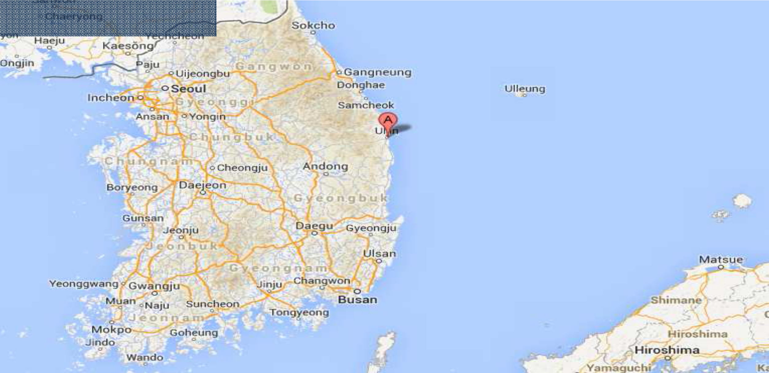Hupo Harbor, Hupo-ri, Hupo-myeon, Uljin-gun, Gyeongsangbuk-do, Korea

Location in Korea

Hupo Harbor

Berthing Area for big boats

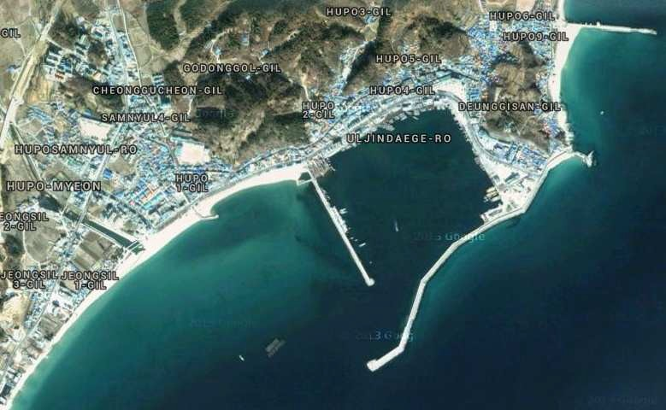Race Office

Berthing Area

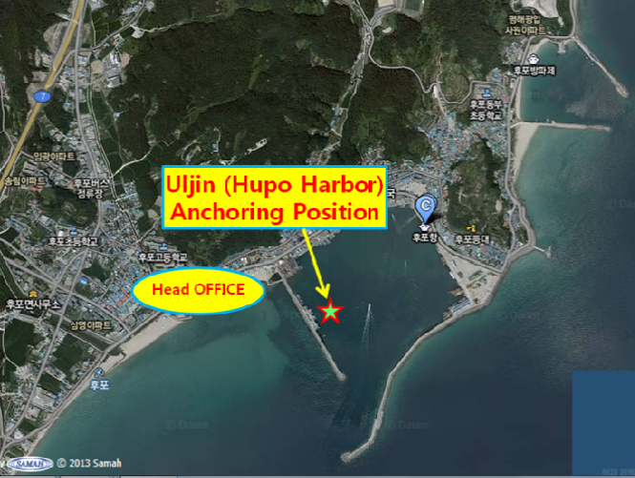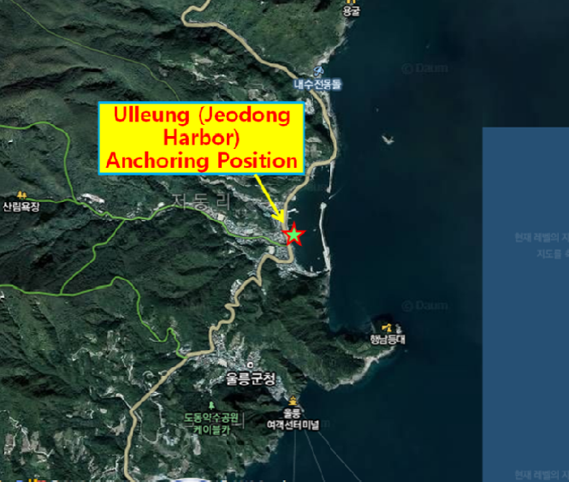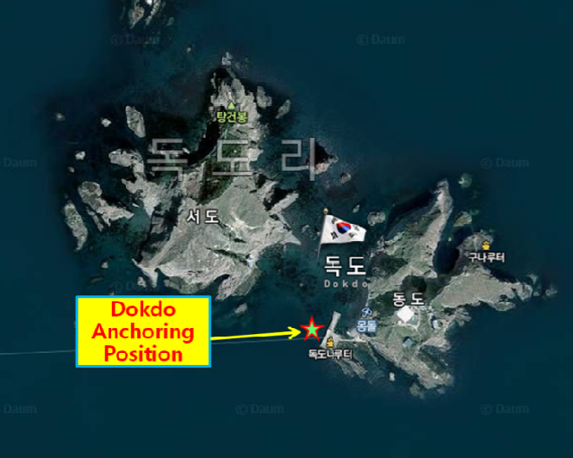
Coordinate of major points

Hupo Harbor in Uljin
Venue for registration, opening ceremony

▪Address:
Hupo-ri, Hupo-myeon, Uljin-gun, Gyeongsangbuk-do, Korea

▪Coordinate: 36˚40'17"N, 129˚27'19'E
(East seawall lighthouse)

Jeodong harborin UlleungIsland
Destination for the offshore leg 1

▪Address:
Dodong-ri, Ulleung-eup, Ulleung-gun, Gyeongsangbuk-do, Korea

▪Coordinate: 37˚29'48"N, 130˚54'48"E
(South seawall lighthouse)

Dokdo
Destination for the friendship parade Starting area for the offshore leg 2

▪Address:
Dokdoisabu-gil, Ulleung-eup, Ulleung-gun, Gyeongsangbuk-do, Korea

▪Coordinate: 37°14′20″N, 131°52′02″E
(East Islanddock)

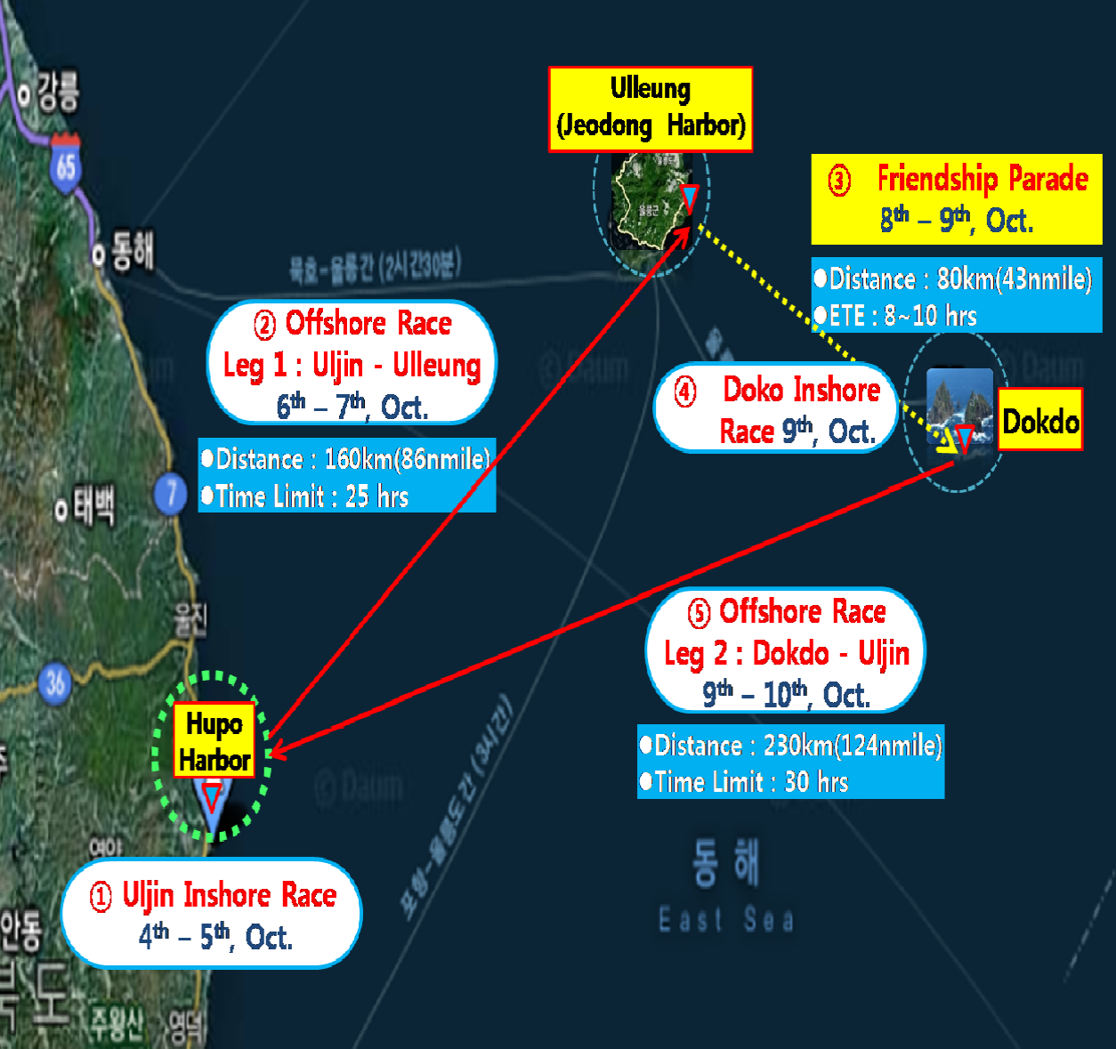

DOKDO START

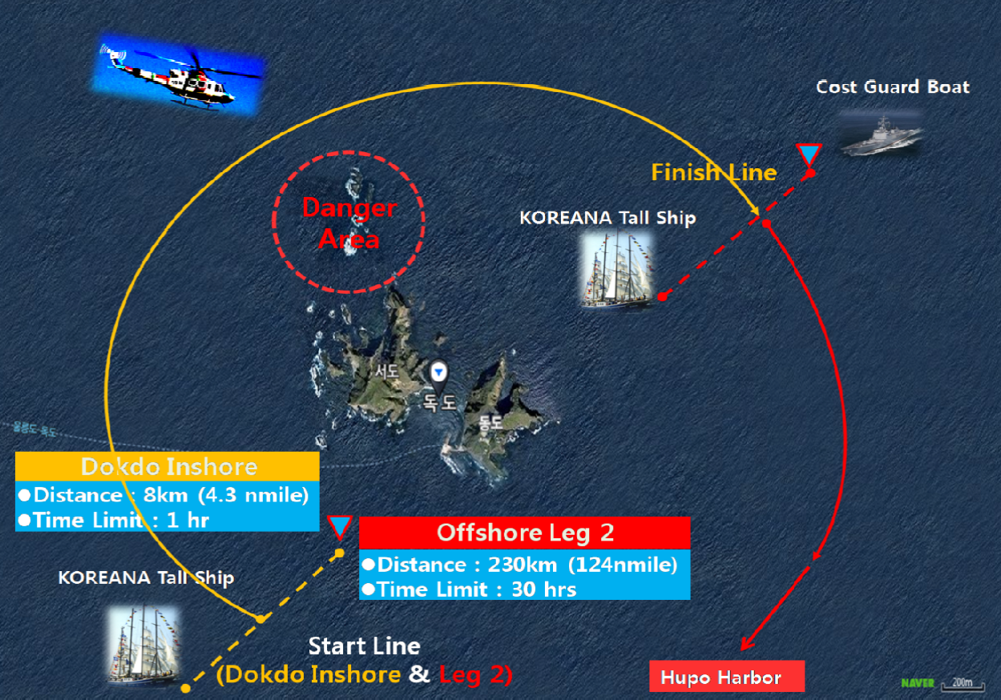

Category |  | Distance | Amount (KRW)
 |  | from the major cities | Up to LOA 12 meters | More than LOA 12 meters
Abroad | 1,000Km and above | Qingdao China 1,057Km | 5,000,000 | 5,500,000
 | Under 1,000Km | Vladivostok Russia 800Km | 4,000,000 | 4,500,000
Domestic | 900Km and above | Ttukseom Seoul 950Km | 5,000,000 | 5,500,000
 | 800Km and above | Ullwangri Incheon 880Km | 4,500,000 | 5,000,000
 | 700Km and above | Boryeong738Km | 4,000,000 | 4,500,000
 | 600Km and above | Kyeokpo 682Km | 3,500,000 | 4,000,000
 | 500Km and above | Mokpo 560Km Seokwipo515Km | 3,000,000 | 3,500,000
 | 400Km and above | Wando 440Km Jejuhang498Km | 2,500,000 | 3,000,000
 | 300Km and above | Yeosu343Km | 2,000,000 | 2,500,000
 | 200Km and above | Tongyeong290Km | 1,500,000 | 2,000,000
 | 100Km and above | Haeundae185Km Susanhang177Km Daepohang190Km | 1,000,000 | 1,500,000
 | 50Km and above | Yangpo95Km Samcheok 92Km | 500,000 | 1,000,000
 | Under 50 Km | Ganggu 36Km | 300,000 | 800,000
- Distance from the Departing Harbor to HupoHarbor in Ulljin.
- The distance shall be calculated by Organizing Authority.

Please this completed form with the necessary documents as per NoR 4 to: Korea Cup International Yacht Race Organizing Committee at ksaf@daum.net Entries close on 31 July 2014.
1. RACES TO ENTER : | All Races □ | / | Uljin Inshore Race Only □
CLASS :  - BOAT | ORC □ | / | OPEN □

- Skipper
Boat name : |  |  |  | Maker: Model :
LOA: |  |  | Beam: |  | Draft :
Engine Make & Model: |  |  |  | Engine Power (in hp):
Home Port: |  |  |  | Owner:

Name: Address: Nationality: Sex: Telephone:
Passport No: Mobile:
Height (cm): Weight (Kg): Email:

Crews

No. | Name | Nationality. | Passport # | e-mail | Others
1 |  |  |  |  | Height(cm): Weigh(kg): | Sex:
2 |  |  |  |  | Height(cm): Weigh(kg): | Sex:
3 |  |  |  |  | Height(cm): Weigh(kg): | Sex:
4 |  |  |  |  | Height(cm): Weigh(kg): | Sex:
5 |  |  |  |  | Height(cm): Weigh(kg): | Sex:
6 |  |  |  |  | Height(cm): Weigh(kg): | Sex:
7 |  |  |  |  | Height(cm): Weigh(kg): | Sex:
8 |  |  |  |  | Height(cm): Weigh(kg): | Sex:
9 |  |  |  |  | Height(cm): Weigh(kg): | Sex:
10 |  |  |  |  | Height(cm): Weigh(kg): | Sex:

- Bank Account Details of the skipper(Remittance of prize money and boat travel support purposes)
Bank: |  | Account Number:
ABA No: |  | Swift Code:
Account Name:  (Beneficiary) |  | Other Information:

Agreement: I agree to be bound by the ISAF Racing Rules of Sailing 2013-2016 (RRS), the ISAF Offshore Special Regulations 2014-2015, ORC Rating rules and the Notice of Race and Sailing Instructionsfor the race(s) concerned.

Skipper’s name: Signature: Date:

The owner or the skipper of the boat is to sign the declaration below.

The following checklist is included for assistance to owners in ensuring that the boat complies with the requirements of the ISAF Offshore Special Regulations for Category 3 Races. The checklist is not comprehensive of all requirements and it is not intended to replace the regulations. Owners should also refer to the full text of the regulations to ensure full compliance.

The official inspectors (or measurers) will be inspecting participating boats in the presence of the owner or the skipper. Boat owners will be notified of the date and time of the inspection and skippers should ensure that the boat is prepared in time. This inspection is carried out only as a guide and an inspector cannot limit or reduce the complete and unlimited responsibility of the owner and the skipper.

1 | The safety of a yacht and her crew is the sole and inescapable responsibility of the person  in charge who must do his best to ensure that the yacht is fully found, thoroughly seaworthy and manned by an experienced crew who have undergone appropriate training and are physically fit to face bad weather. He must be satisfied as to the soundness of hull, spars, rigging, sails and all gear. He must ensure that all safety equipment is properly maintained and stowed and that the crew knows where it is kept and how it is to be used. | □
2 | Navigation lights shall not be mounted below deck level and should be at no less height  than immediately under the upper lifeline. | □
3 | Navigation lights, stem lights, stern lights shall be checked. | □
4 | A passive Radar Reflector (that is, a Radar Reflector without any power) shall be  provided | □
5 | Attached to through-bolted or welded deck plates or other suitable and strong anchorage  fitted on deck, port and starboard of the yacht's centre line to provide secure attachments for safety harness | □
6 | - Completely fixed, a clipping crew should be stand easy to work at lifeline on the deck.  - The lifeline is stainless steel wire (LOA 8.5m~13m ,silver 4mm over than) not be provided plastic clothing and the yacht which uses sheet or sleeve shall be inspected regularly. | □
7 | During a race, can be charged of the battery, fuel of more than 20L available 8 hours by  minimum speed and water of more than 20L for emergency survival shall be provided. | □
8 | A marine magnetic compass, independent of any power supply, permanently installed  and correctly adjusted with deviation card. | □
9 | An anchor that’s ready for immediate use with 2 or more adequate rope and chain | □
10 | Foghorn | □
11 | Two or more adequately placed fire extinguishers that’s ready for immediate use. | □
12 | Tools and Spare Parts  Tools and spare parts, including effective means to quickly disconnect or sever the standing rigging from the hull (wire cutter)
13 | Yacht's name  Yacht's name shall be on all miscellaneous buoyant equipment | □

14 | Battery Systems  When an electric starter is the only method for starting the engine, the yacht shall have a separate battery, the primary purpose of which is to start the engine | □
15 | A First Aid Kit | □
16 | Marine radio transceiver VHF: that has a rated output power of 25W | □
17 | Fixing or handheld GSP | □
18 | A sailing sea chart (not electronic), lighthouse list and working tools. | □
19 | A lifebuoy with a self-igniting light and a drogue or a Lifesling with a self-igniting light  and without a drogue. | □
20 | 2 red parachute and 2 red hand flares and cyalume-type chemical light sticks (red flares  compliant with SOLAS) | □
21 | 2 Orange smokescreen | □
22 | A waterproof flashlight with spare batteries and bulb | □
23 | Each crew member shall have a lifejacket as follows:-  In accordance with ISO 12402 – 3 (Level 150) or equivalent, ISO 12402 requires Level 150 lifejackets to be fitted with a mandatory whistle and retro-reflective material. Also, when fitted with a safety harness, ISO 12402 requires that this shall be the full safety harness in accordance with ISO 12401. Any equivalent lifejacket shall have equal requirements. | □
24 | Snap hook on each end no longer than 2m and safety line and harness for each member  on board | □
25 | Emergency steering | □
26 | Each sized coak should be provided the holes through the yacht (bilge-pump, water  pump, speed gauge and toilet. etc ) | □

DECLARATION: “I HEREBY DECLARE that I am the owner or person in charge of the above yacht, that I have read and understood the requirements of the ISAF Offshore Special Regulations 2014-2015, in particular 1.02.1, 1.02.2, and 1.02.3 (Responsibility of Person in Charge)”, and that the yacht complies with the requirements of the Regulations for Category 3 races.

Name of boat:

Printed Name:

Signature:

Date:

