

**------------------------------------------------------------------------------------------------**

**2000 Islands International Regatta 2014**

**Notice of Regatta**

**------------------------------------------------------------------------------------------------**

**1. Regatta Name and Summary**

1.1. Name : 2000 Islands International Regatta 2014

1.2. Period : 24(Thu) April ~ 27(Sun) April, 2014 / 4 days

1.3. Events : Inshore (Mokpo Peace Agora Waters)

Offshore (Heuksando-Hongdo-Heuksando)

Parade (Mokpo-Heuksando)

1.4. Host : Ministry of Maritime Affairs and Fisheries, Jeollanam-do,

Mokpo-si, Shinan-gun

1.5. Supervision : Sehan University Industry-Academic Cooperation

Foundation (SRL M.L.S. Foundation),

Mokpo City Sailing Federation

1.6. Sponsor : Korea Sailing Federation, Jeonnam Sailing Federation,

Mokpo MBC, Korea Maritime Foundation, Marina Industries

Association of Korea, Korea Maritime Leisure Network

1.7. Cooperation Organization : West Regional Headquarters Korea Coast

Guard, Mokpo Coat Guard, Mokpo Regional Maritime Affairs

and Port Office, The 3rd Navy Fleet Headquarters, Mokpo

Customs, Mokpo Immigration Office, Mokpo VTS, Mokpo

Yacht Marina

**2. Rules**

2.1. This regatta will be governed by the rules as defined in The Racing

Rules of Sailing 2013-2016 of ISF, PHRF for OPEN class, Special

Handicap System for 2000 Islands International Regatta, Notice of

Regatta and Sailing Instructions.

2.2. If there is a conflict between NOR and SI, SI will take precedence.

(This changes RRS 63.7)

2.3. If there is conflict between languages the English text will take

precedence.

**3. Event Advertising**

3.1. This regatta is category C, all boats shall display event advertising and

entry number supplied by the organizing authority.

3.2. A boat can be required to carry passengers from event sponsor or

media and equipments.

**4. Class and Qualifications**

4.1. Class : OPEN Class.

4.2. Qualifications

- Mono-hull keel boat over 30ft.

- Multi-hull (Catamaran and Trimaran) and the others are possible to

participate for the extra round.

- The number of boats will be restricted under 30 in order registered.

4.3. Application for participation

- All competitors have to complete an application for participation

(Att. 5) with a written oath (Att. 6) and have to submit to the organizing

authority by 17:00hrs 28(Fri) March, 2014.

(e-mail: dadohaecup@gmail.com)

- Organizing authority shall be early closed the application before the

submission date for the safety and progress of the regatta.

- Organizing authority shall decide the participation for the competitors

who submit after the submission date.

- All competitors who have submitted the application have to register by

17:00hrs 24(Thu) April, 2014 to the regatta committee.

4.4. The final decision of the competitors who have submitted the application

shall decide by the organizing authority for the safety and progress of

the regatta.

4.5. The minimum number of sailors are over 4 including skipper for the

safety and accurate sailing of the regatta.

4.6. Korean nationality competitors should be a member of Korea Sailing

Federation.

4.7. Competitor boats’ nationality comply with owner’s nationality and in

case of charter boats comply with skipper’s nationality.

**5. Entry Fee**

5.1. Entry fee has to pay when submit the registration as follows:

- 100,000KRW/boat + 20,000KRW/person

5.2. Entry fee is able to remittance also as follows:

- Bank Name: Gwangju Bank

- Account Name: Sehan University Industry-Academic Cooperation

Foundation

- Account Number: 606-127-002327

- Please include boat owner’s name, name of team or skipper’s name

when make a remittance.

5.3. Paid entry fees are not refundable if the competitor will not participate

the regatta but will refund to competitors’ bank account which stated

on the application if the regatta will be not held.

**6. Schedule of Regattas**

|  |  |  |  |
| --- | --- | --- | --- |
| Date | Time | Schedule | Remark |
| 24(Thu) April | 09:00 ~ 17:00 | - Registration, Measurement,  Safety Inspections | Mokpo Yacht Marina |
| 25(Fri) April | 09:00 ~ 09:30 | - Skippers Meeting | Education Room |
| 11:00 ~ 14:00 | - Inshore Regatta | Mokpo Peace Agora Waters |
| 16:10 ~ 18:30 | - Opening Ceremony | Mokpo Yacht Marina |
| 26(Sat) April | 06:00 ~ 06:30 | - Ship’s clearance report | Education Room |
| 06:30 ~ 17:30 | - Parade | Mokpo to Heuksando |
| 19:30 ~ 20:00 | - Skippers Meeting | Heuksando Ferry Terminal |
| 27(Sun) April | 06:00 ~ 12:00 | - Offshore Regatta | Heuksando-Hongdo-Heuksando |
| 13:00 ~ 16:00 | - Prize Giving and Closing Ceremony | Heuksando Ferry Terminal |

**7. Equipment and Measuring Checks**

7.1. A boat or equipment may be inspected at any time for compliance with

the class rules and sailing instructions.

7.2. All boats have to complete the manufacturer and model name and

specifications of the boat in the application for participation.

7.3. On the water, substitution shall be made to the committee at the first

reasonable opportunity.

**8. Sailing Instruction**

8.1. Sailing Instruction will distribute at the regatta committee when the

competitors registration.

**9. The Courses**

9.1. Inshore Regatta : Mokpo Peace Agora Waters / Att. 2

9.2. Offshore Regatta : Heuksando – Hongdo – Heuksando / Att. 3

9.3. Parade : Mokpo – Heuksando / Att. 4

9.4. The course and waters of regatta can be changed according to the

wind condition.

**10. Penalty System and Protests**

10.1. Rule 44.1 and 44.2 will apply. This can be changed by decision of

the RC.

10.2. Organization authority will form a protest committee.

10.3. Decisions of the protest committee will be final as provided in Korea

Sailing Federation Regulation 4.1.

**11. Scoring and Rating**

11.1. Low point system of RRS A4 will apply for this regatta.

11.2. PHRF will apply for OPEN class

11.3. All changes and additional will be specified in the Sailing Instructions.

**12. Official Boats**

12.1. Official boats will raise a flags which the organization authority has

designated flags.

**13. Mooring**

13.1. All boats have to moor in the places where the organization authority

has designated places.

**14. Haul-Out Restrictions**

14.1. All boats shall not be hauled out during the regatta except with and

according to the terms of prior written permission of the RC.

**15. Radio Communication**

15.1. All boats’ radio communication device(Marine VHF) shall be opened

all the times during the regatta on the channel designated by the RC.

15.2. And, over 2 connectable personal mobile phones have to operate in

a boat.

15.3. All boats when move from Mokpo to Heuksando have to report the

regular position requested by the RC. However, the method and

ways will be noticed by the Sailing Instructions and supported.

**16. Prizes and Sail-back Subsidy**

16.1. Prizes (Mokpo Inshore Regatta)

|  |  |  |
| --- | --- | --- |
| Placing | Prizes | Remark |
| First Finish | Trophy and Prize Money: 500,000KRW |  |
| 1st | Trophy and Prize Money: 1,000,000KRW |  |
| 2nd | Trophy and Prize Money: 800,000KRW |  |
| 3rd | Trophy and Prize Money: 600,000KRW |  |

16.2. Prizes (Heuksando-Hongdo-Heuksando Offshore Regatta)

|  |  |  |
| --- | --- | --- |
| Placing | Prizes | Remark |
| First Finish | Trophy and Prize Money: 700,000KRW |  |
| 1st | Trophy and Prize Money: 2,000,000KRW |  |
| 2nd | Trophy and Prize Money: 1,500,000KRW |  |
| 3rd | Trophy and Prize Money: 1,000,000KRW |  |
| 4th | Trophy and Prize Money: 800,000KRW |  |
| 5th | Trophy and Prize Money: 600,000KRW |  |

16.3. Sail-back and Parade Subsidy

|  |  |  |  |
| --- | --- | --- | --- |
| Miles | | KRW | Remark |
| Sail-back and Parade Subsidy | Less than 100 miles | 1,000,000 | Mokpo/Jeju/Gunsan |
| 100 ~ less than 200 miles | 1,500,000 | Busan/Incheon |
| 200 ~ less than 300 miles | 2,000,000 | Hoopo |
| More than 300 miles | 3,000,000 | Susan/Uljin/Overseas |

1) The total amount of prize money will be changed according to the number of competitors

2) Sail-back and Parade Subsidy applies from the competitors’ home-port or out-port before 30 days

of the regatta beginning (The overseas competitors apply also if them have stayed in Korea

already).

3) All boats have to submit a copy of clearance bill when out-port their country to the organization

authority when submit the registration.

4) All competitors have to submit a bank statement details and copy of passport of boat owner,

representative of team or skipper to the organization authority when submit the registration to make

remittance the prize or sail-back and parade subsidy money.

5) The prize money will be the amount of tax deducted according to the tax law (including overseas

competitors).

6) The competitors who have rejected participation or have not finished the event to the end without

reasonable cause, the sail-back and parade subsidy may not be paid by organizing authority.

**17. Safety Regulation**

17.1. By the OSR 1.02 rules, all competitors are each individually

responsible for their safety and care.

17.2. The details for the safety(check list etc) during the regatta will be

distributed after finalize the competitors.

**18. Disclaimer of Liability**

18.1. The competitors participate in the regatta entirely at their own risk.

18.2. All competitors are each individually responsible for their safety

during the regatta.

18.3. The organizing authority will not accept any liability for material

damage or personal damage or death sustained in conjunction with

or prior to, during, or after the regatta.

**19. Insurance**

19.1. All competitors have to take up an insurance policy on damage for

humans.

**20. Organization Authority**

19.1. Name : Organization Authority of “2000 Islands

International Regatta 2014”.

19.2. Location : Mokpo Yacht Marina

Sehan University Industry-Academic Cooperation

Foundation (SRL M.L.S. Foundation)

88-56, Samhak-ro, Mokpo-si, Jeollanam-do, KOREA

19.3. Contact : OH, Jang-Uk / ph: +82 61 243 9911 / fax: +82 61 243 9910

e-mail: dadohaecup@gmail.com

web-site: www.mokpo-marina.co

Att. 1 : Events

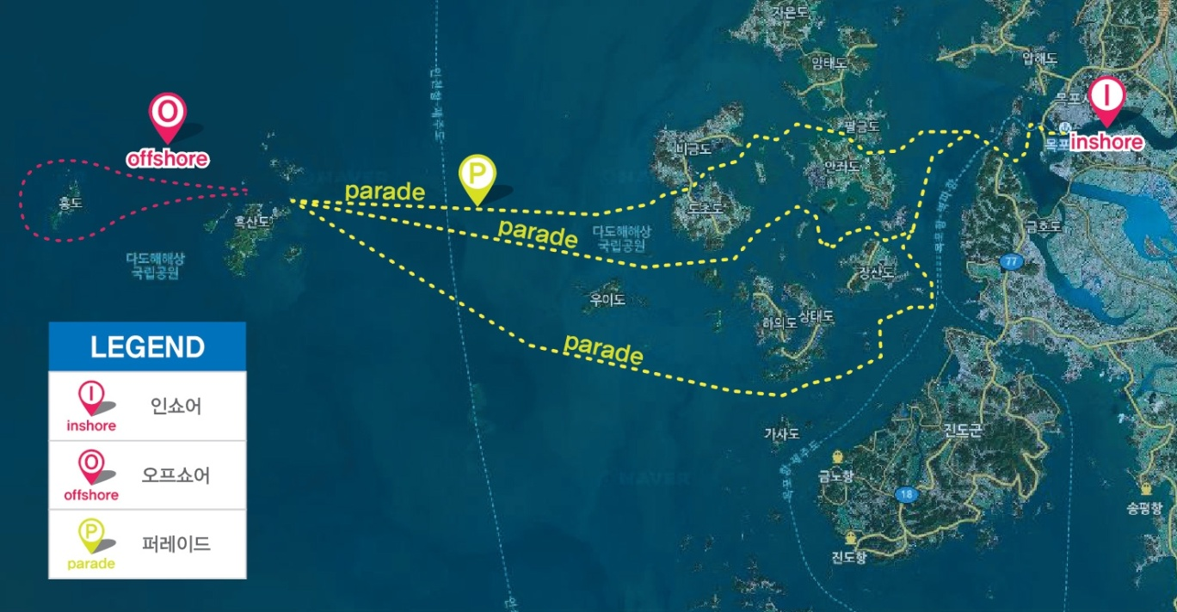

Att. 2 : Mokpo Peace Agora Waters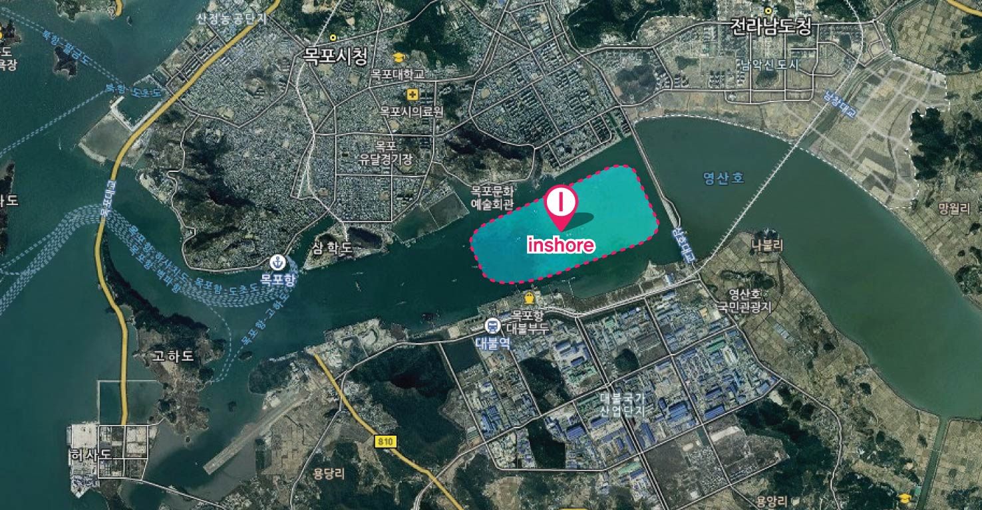 (Inshore Regatta)

The course and waters of regatta can be changed according to the wind condition.

Att. 3 : Heuksando - Hongdo – Heuksando (Offshore Regatta)

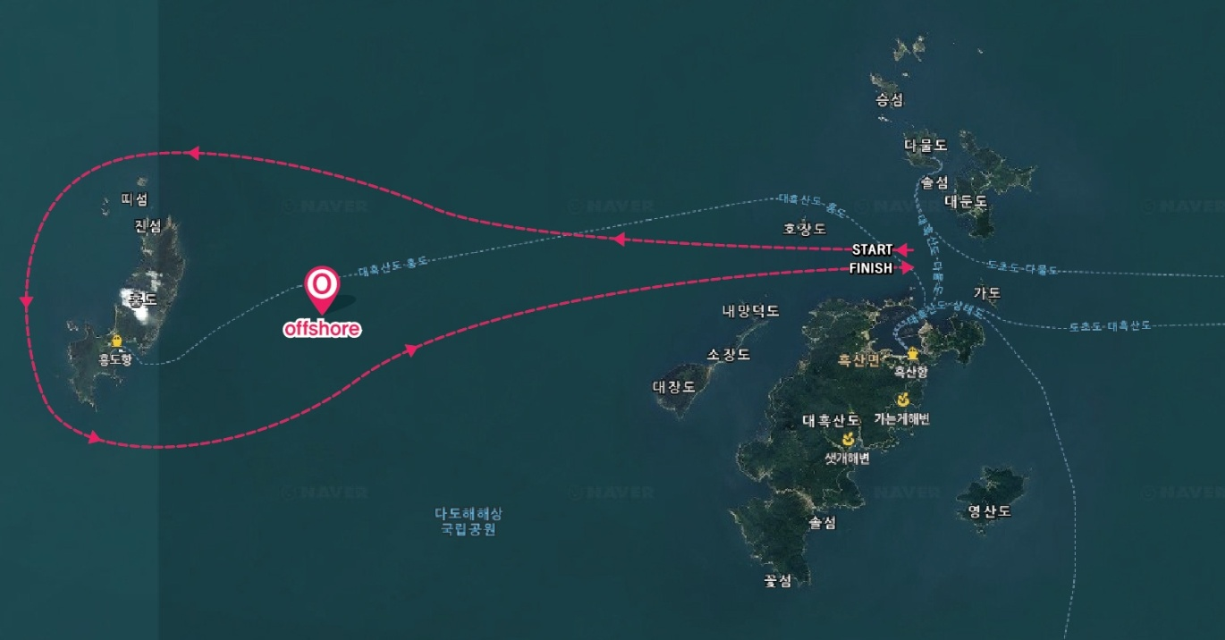

The course and waters of regatta can be changed according to the wind condition.

Att. 4 : Parade (Mokpo – Heuksando)

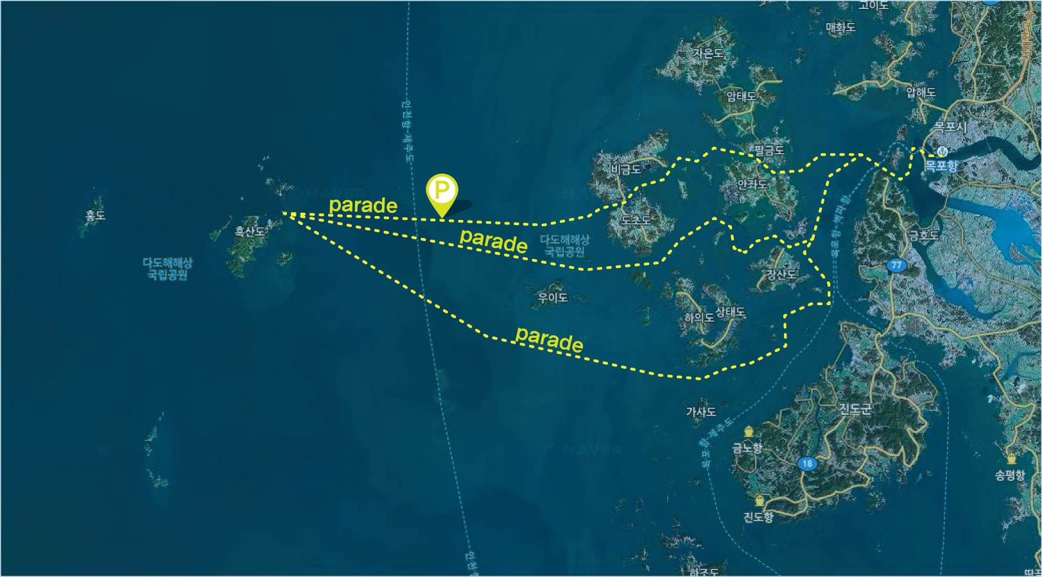

The course and waters of parade can be changed according to the wind condition.

Att. 5 : Application for Participation

|  |  |  |  |  |  |  |  |  |  |  |  |  |  |  |  |  |
| --- | --- | --- | --- | --- | --- | --- | --- | --- | --- | --- | --- | --- | --- | --- | --- | --- |
| **2000 Islands International Regatta 2014**  **Application for Participation** | | | | | | | | | | | | | | | | |
| Specifications of Yacht | | | | | | | | | | | | | | | | |
| Yacht  Name | |  | | | Manufacturer | |  | | | Model  Name |  | | Sail  Number | | |  |
| Out-port | |  | | | LOA | | ft | | | LOW | ft | | Weight | | | ton |
| Skipper | | | | | | | | | | | | | | | | |
| Name | | | I/D Number | | | | | Address | | | | | | Mobile Phone | | |
|  | | |  | | | | |  | | | | | |  | | |
| Crew | | | | | | | | | | | | | | | | |
|  | Name | | | Date of Birth | | | | | Address | | | | | Mobile Phone | | |
| 1 |  | | |  | | | | |  | | | | |  | | |
| 2 |  | | |  | | | | |  | | | | |  | | |
| 3 |  | | |  | | | | |  | | | | |  | | |
| 4 |  | | |  | | | | |  | | | | |  | | |
| 5 |  | | |  | | | | |  | | | | |  | | |
| 6 |  | | |  | | | | |  | | | | |  | | |
| 7 |  | | |  | | | | |  | | | | |  | | |
| 8 |  | | |  | | | | |  | | | | |  | | |
| 9 |  | | |  | | | | |  | | | | |  | | |
| 10 |  | | |  | | | | |  | | | | |  | | |
| Bank Account Details | | | | | | | | | | | | | | | | |
| Bank | | | |  | | Account Number | | | |  | | Account Name | | |  | |
| On behalf of my team, I pledge to abide by its Racing Rules of Sailing of ISF, PHRF for  OPEN class, Special Handicap System for 2000 Islands International Regatta 2014,  Notice of Regatta and Sailing Instructions. | | | | | | | | | | | | | | | | |
| 2014. . .  Skipper Signature | | | | | | | | | | | | | | | | |

Att. 6 : Written Oath

|  |
| --- |
| **2000 Islands International Regatta 2014**  **Written Oath** |
| Name: Date of Birth :  Address:  I (skipper or representative of team) take an oath that I will not blame and will not objections of the criminal and civil suits if the criminal and civil accidents occur caused by the personal and team member though one’s carelessness and poor management to Sehan University Industry-Academic Cooperation Foundation (SRL M.L.S. Foundation) and Organization Authority of this Regatta.  2014. . .  Name : (signature)  Attn:  Sehan University Industry-Academic Cooperation Foundation |

Att. 7 : Long Distance Water Leisure Activity Card

|  |  |  |  |  |  |  |  |  |  |  |  |  |  |  |  |  |  |
| --- | --- | --- | --- | --- | --- | --- | --- | --- | --- | --- | --- | --- | --- | --- | --- | --- | --- |
|  | | | | | | | | | | | | | | | | | |
| **Long Distance Water Leisure Activity Card** | | | | | | | | | | | | | | | | | |
| Declaration  Person | | | Name | |  | | | I/D Nimber | | | |  | | | | | |
| Address | |  | | | Mobile  Phone | | | |  | | | | | |
| Boat  Specifications | | | Type | |  | | | Name | |  | | Tonnage | | | t | | |
| Material | |  | | | Maximum  Passenger | |  | | Passenger  Number | | |  | | |
| Report Details | | | | | | | | | | | | | | | | |  |
| Sailing | | | | | | | | | | | Port Entry | | | | | | |
| Date | | Out port | | | Expected | | | | Confir-  mation | | Date | | Port of  Entry | | | Confir-mation | |
| Date | Port | | |
|  | |  | | |  |  | | |  | |  | |  | | |  | |
| Passenger | Name | | | I/D Number | | | Address | | | | | | | Mobile Phone | | | |
|  | | |  | | |  | | | | | | |  | | | |
|  | | |  | | |  | | | | | | |  | | | |
|  | | |  | | |  | | | | | | |  | | | |
|  | | |  | | |  | | | | | | |  | | | |
|  | | |  | | |  | | | | | | |  | | | |
|  | | |  | | |  | | | | | | |  | | | |
| I report in accordance with the “Law of Water Leisure Safety” act 19.1 and act  15 as the above.  2014. . .  Name (signature)  Attn: the Chief of Mokpo Coast Guard | | | | | | | | | | | | | | | | | |